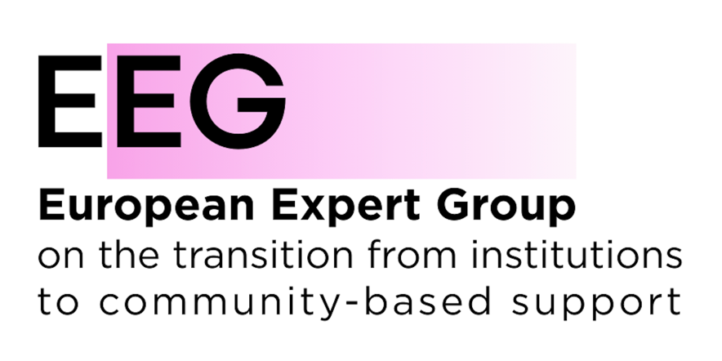

EEG Submission on the UN CRPD Draft guidelines on intersectional discrimination against women and girls with disabilities

Introduction
The European Expert Group on the transition from institutional to community-based care (EEG) is a European coalition of civil society organisations, public authorities, service providers, and international organisations working to replace institutionalisation with family- and community-based care and support across Europe.

General comments
The EEG welcomes the draft Guidelines and their strong focus on the intersection of disability and gender, including the recognition of the heightened risks of discrimination, exclusion and violence faced by women and girls with disabilities.
The EEG particularly welcomes the references to article 19 of the Convention and the recognition of the links between institutionalisation, violence and discrimination.
The EEG proposes several additions to further strengthen the role of community-based living systems and deinstitutionalisation in advancing gender equality and preventing intersecting forms of discrimination. In particular, while the draft recognises the disproportionate institutionalisation of women and girls with disabilities, it could further highlight the role of institutionalisation as a factor that deepens and reinforces intersecting forms of discrimination and exclusion.
The transition to community-based living systems is not only a disability rights issue but also a gender equality issue. Accessible and quality support services can reduce the pressure on families to rely on institutional care and help address structural inequalities affecting women and girls.

Specific comments and suggested addition

Paragraph 43
To add "Institutionalization itself may intensify and compound existing forms of discrimination by increasing dependency, limiting access to justice, education, employment and participation, and exposing women and girls with disabilities to heightened risks of violence, abuse and exploitation." at the end of the peregraph.

Paragraph 77
To add "States parties should recognize that the transition from institutional systems to community-based living systems contributes to gender equality by reducing reliance on unpaid care and expanding opportunities for women and girls with disabilities and their family members to participate in education, employment and community life." at the end of the paragraph.

