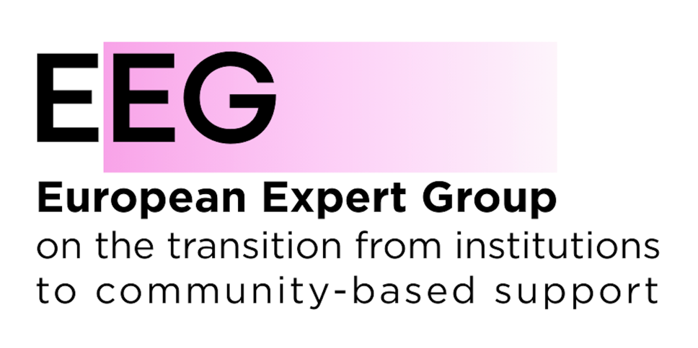

To the <Commission>{EMPL}Committee on Employment and Social Affairs, European Parliament</Commission></Depute>
12/05/2026

EEG Targeted Amendments to the<RefProcLect></RefProcLect> <TitreType>Draft Report
<Titre>on the proposal for a regulation of the European Parliament and of the Council establishing the European Social Fund as part of the National and Regional Partnership Plan set out in Regulation (EU) […] [NRPPlan] establishing conditions for the implementation of the Union support to quality employment, skills and social inclusion for the period from 2028 to 2034</Titre>
<DocRef>(COM(2025)0558 – C10-0172/2025 – 2025/0239(COD))</DocRef>

Explanatory Statement
The European Expert Group on the transition from institutional to community-based care (EEG) is a European coalition of civil society organisations, public authorities, service providers and international organisations working to advance deinstitutionalisation and promote community-based, rights-based systems of support across Europe.
The EEG welcomes the important role of the European Social Fund (ESF) in promoting social inclusion, equal opportunities and access to quality services. As the Union’s main instrument supporting social inclusion and employment, the ESF must also contribute to preventing segregation and institutionalisation and to supporting the transition towards community-based services and independent living.
Across the European Union, around 1.5 million people, including children, persons with disabilities and people experiencing homelessness, continue to live in institutional or segregated settings, often deprived of autonomy, participation and inclusion in society. Despite existing EU commitments and funding, institutionalisation persists and EU funds continue, in some cases, to support institutional and segregating models of care and support.
The European Union has a particular responsibility in this area as a party to the United Nations Convention on the Rights of Persons with Disabilities (CRPD). The CRPD, together with the Charter of Fundamental Rights of the European Union and the United Nations Convention on the Rights of the Child, requires the Union and Member States to promote independent living, community inclusion and non-discrimination.
The proposed amendments therefore aim to strengthen the ESF as a tool for social inclusion and fundamental rights by:
- recognising deinstitutionalisation and prevention of segregation among the objectives of the Fund;
- ensuring compliance with the CRPD and other fundamental rights instruments as horizontal principles;
- supporting investment in family-based and community-based services;
- preventing the use of EU funding for the creation, renovation, expansion or modernisation of institutional and segregating settings.
These amendments seek to ensure that EU funding supports structural reforms towards inclusive, community-based systems and does not contribute to segregation or exclusion.
The EEG proposed additions are highlighted in yellow.

</Amend>
</Amend>
</Amend>
<Amend>Amendment <NumAm>14</NumAm>
<DocAmend>Proposal for a regulation</DocAmend>
<Article>Recital 15</Article>
Text proposed by the Commission | Amendment
(15) The ESF should facilitate access to services, including the strengthening of the modernisation, digitalisation and the resilience of both healthcare and long-term care services. The ESF should support Member States in implementing measures to eliminate all forms of discrimination and ensure equal opportunities for all, and in particular for groups that are under-represented in the labour market, ensuring equal access to services. The availability of affordable, sustainable and high-quality services such as early childhood education and care, out-of-school care, education, training, and health and long-term care, in particular family and community-based care services, is a necessary condition for ensuring equal opportunities and labour mobility. The ESF should ensure that everyone, including children in line with the European Child Guarantee, have access to essential services of good quality. The specific needs of persons with disabilities, including accessibility, should be taken into account in relation to those services as well as independent living. The ESF should also contribute to the modernisation of social protection systems with a view in particular to promoting their accessibility. | (15) In order to address the persistently high level of child poverty in the Union, and in line with Principle 11 of the European Pillar of Social Rights, which states that children have the right to protection from poverty and that children from disadvantaged backgrounds have the right to specific measures to enhance equal opportunities, Member States should implement the Child Guarantee. The Child Guarantee has a dedicated budget. The ESF should facilitate access to services, including the strengthening of the modernisation, digitalisation and the resilience of both healthcare and long-term care services. The ESF should support Member States in implementing measures to eliminate all forms of discrimination and ensure equal opportunities for all, and in particular for groups that are under-represented in the labour market, ensuring equal access to services. The availability of affordable, sustainable and high-quality services such as early childhood education and care, out-of-school care, education, training, and health and long-term care, in particular family and community-based care services, is a necessary condition for ensuring equal opportunities and labour mobility. The ESF should ensure that everyone, including children in line with the European Child Guarantee, have access to essential services of good quality. The specific needs of persons with disabilities, including accessibility, should be taken into account in relation to those services as well as independent living. The ESF should support the transition from institutional to family-based and community-based care. The ESF should also contribute to the modernisation of social protection systems with a view in particular to promoting their accessibility.
Or. <Original>{EN}en</Original>
</Amend></Amend>
<Amend>Amendment <NumAm>17</NumAm>
<DocAmend>Proposal for a regulation</DocAmend>
<Article>Recital 18</Article>
Text proposed by the Commission | Amendment
(18) Regulation (EU) [National Plan Regulation] requires that Member States respect horizontal principles in the preparation and implementation of the national and regional partnership plans. In this context, Member States should also be encouraged to use the ESF to supports targeted actions to promote horizontal principles such as the promotion of gender equality and ensuring the accessibility of services for people with disabilities and to enable people with disabilities to actively participate. | (18) Member States shall respect horizontal principles in the preparation and implementation of their programmes. In this context, Member States should also be encouraged to use the ESF to supports targeted actions to promote horizontal principles such as the promotion of gender equality and ensuring the accessibility of services for people with disabilities and to enable people with disabilities to actively participate. The implementation of the ESF should respect the principles and values of Article 2 of the Treaty on European Union, and the Charter of Fundamental Rights of the European Union and the United Nations Convention on the Rights of Persons with Disabilities. Member States should also respect the obligations set out in the United Nations Convention on the Rights of the Child. The ESF should not support actions that contribute to any form of segregation or exclusion.
Or. <Original>{EN}en</Original>
</Amend></Amend></Amend>
<Amend>Amendment <NumAm>23</NumAm>
<DocAmend>Proposal for a regulation</DocAmend>
<Article>Article 1 b (new)</Article>
Text proposed by the Commission | Amendment
 | Article 1b
 | General objectives of the ESF
 | 1. The ESF aims to support Member States and regions to achieve high employment levels, fair social protection and a skilled and resilient workforce ready for the future world of work, as well as inclusive and cohesive societies aiming to eradicating poverty and delivering on the principles set out in the European Pillar of Social Rights and the headline targets of the Action Plan of the European Pillar of Social Rights.
 | 2. The ESF shall support, complement and add value to the policies of Member States to ensure equal opportunities, equal access to the labour market, fair working conditions, social protection and inclusion. In particular, it shall promote the creation of quality jobs, as well as focusing on quality and inclusive education and training, lifelong learning, investment in children and young people and access to basic services.
 | 3. The ESF aims to support Member States towards combat all forms of discrimination and segregation and to achieving high social and economic inclusion, especially for groups and people in vulnerable situations.
Or. <Original>{EN}en</Original>
</Amend></Amend>
<Amend>Amendment <NumAm>25</NumAm>
<DocAmend>Proposal for a regulation</DocAmend>
<Article>Article 2 – paragraph 1</Article>
Text proposed by the Commission | Amendment
(1) The European Social Fund (ESF) shall support the specific objectives set out in Article 3 of Regulation XX [NRP Plan Regulation]. | (1) The ESF shall support the following specific objectives in the policy areas of employment and labour mobility, education, social inclusion, including contributing to poverty eradication:
 | (a) improving access to employment and activation measures for all jobseekers, in particular young people, especially through the implementation of the Youth Guarantee, for long-term unemployed and groups in a disadvantaged position on the labour market, for persons with disabilities or chronic diseases, and for inactive people, as well as through the promotion of self-employment and the social economy;
 | (b) modernising labour market institutions and services to assess and anticipate skills needs and ensure timely and tailor-made assistance and support for labour market matching, transitions and mobility;
 | (c) promoting a gender-balanced labour market participation, equal working conditions, and a better work-life balance including through access to affordable childcare, and care for dependent persons;
 | (d) promoting the adaptation of workers, enterprises and entrepreneurs, active and healthy ageing and a healthy and well-adapted working environment that addresses health risks;
 | (e) improving the quality, inclusiveness, effectiveness and labour market relevance of education and training systems including through validation of non-formal and informal learning, to support acquisition of key competences including entrepreneurial and digital skills, and by promoting the introduction of dual-training systems and apprenticeships;
 | (f) promoting equal access to and completion of quality and inclusive education and training, in particular for groups in disadvantaged positions, from early childhood education and care through general and vocational education and training, to tertiary level, as well as adult education and learning, including facilitating learning mobility for all and accessibility for persons with disabilities;
 | (g) promoting lifelong learning, in particular flexible upskilling and reskilling opportunities for all taking into account entrepreneurial and digital skills, better anticipating change and new skills requirements based on labour market needs, facilitating career transitions and promoting professional mobility;
 | (h) promoting women’s employment and the social and economic inclusion of women;
 | (i) fostering active inclusion with a view to promoting equal opportunities, non-discrimination and active participation, and improving employability, in particular for groups in vulnerable positions;
 | (j) promoting the socio-economic integration of third-country nationals;
 | (k) promoting the socio-economic integration of marginalised communities, such as Roma people;
 | (l) enhancing equal and timely access to quality, sustainable and affordable services, including services that promote the access to housing and person-centred care including healthcare; promoting the transition from institutional to family-based and community-based care; modernising social protection systems, including promoting access to social protection, with a particular focus on children and groups in a disadvantaged position; improving accessibility including for persons with disabilities, effectiveness and resilience of healthcare systems and long-term care services;
 | (m) promoting the social inclusion integration of people at risk of poverty or social exclusion, including the most deprived persons and children;
 | (n) addressing material deprivation through food and/or basic material assistance to the most deprived persons, including children, and providing accompanying measures supporting their social inclusion;
 | (o) facilitating the just transition through reskilling and job creation, emphasising on decent work;
 | (p) addressing homelessness.
Or. <Original>{EN}en</Original>
</Amend></Amend>
<Amend>Amendment <NumAm>33</NumAm>
<DocAmend>Proposal for a regulation</DocAmend>
<Article>Article 5 b (new)</Article>
Text proposed by the Commission | Amendment
 | Article 5b
 | Horizontal principles
 | 1. Member States shall design the measures in the programme in a way that ensures respect for:
 | (a) the principles of the rule of law as set out in Article 2, point (a), and Article 3 of Regulation (EU, Euratom) 2020/2092 of the European Parliament and of the Council^{1a};
 | (b) the rights, freedoms and principles set out in the Charter of Fundamental Rights of the European Union and the UN Convention on the Rights of Persons with Disabilities.
 | 2. The Commission and the Member States shall ensure that gender equality, gender mainstreaming and the integration of gender perspective are taken into account and promoted throughout the preparation, implementation, monitoring, reporting, and evaluation of the ESF. Member States and the Commission shall aim to increase the participation of women in employment as well as conciliation between working and personal life, combat the feminisation of poverty and gender discrimination in the labour market and in education and training.
 | 3. The Commission and the Member States shall take appropriate steps to prevent any discrimination based on gender, racial or ethnic origin, religion or belief, disability, age or sexual orientation during the preparation, implementation, monitoring, reporting, and evaluation of the operations of the ESF.
 | 4. Member States and the Commission shall ensure respect for fundamental rights and compliance with the Charter of Fundamental Rights of the European Union and the UN Convention on the Rights of Persons with Disabilities in the implementation of the ESF.
 | 5. Articles 8 and 9 of [NRPP Regulation] shall apply, mutatis mutandis, to the implementation of the ESF.
 | __________________
 | ^{1a} Regulation (EU, Euratom) 2020/2092 of the European Parliament and of the Council of 16 December 2020 on a general regime of conditionality for the protection of the Union budget (OJ L 433I, 22.12.2020, p. 1, ELI: http://data.europa.eu/eli/reg/2020/2092/oj).
Or. <Original>{EN}en</Original>
</Amend></Amend>
<Amend>Amendment <NumAm>35</NumAm>
<DocAmend>Proposal for a regulation</DocAmend>
<Article>Article 5 d (new)</Article>
Text proposed by the Commission | Amendment
 | Article 5d
 | Eligibility
 | 1. The following costs shall not be eligible for general support from the ESF strand under shared management:
 | (a) the purchase of land and real estate as well as infrastructure; and
 | (b) the purchase of furniture, equipment and vehicles, except where such purchase is necessary for achieving the objective of the operation, or those items are fully depreciated during the operation, or the purchase of those items is the most economic option.
 | 2. Contributions in kind in the form of allowances or salaries disbursed by a third party for the benefit of the participants in an operation may be eligible for a contribution from general support from the ESF strand under shared management provided that the contributions in kind are incurred in accordance with national rules, including accountancy rules, and do not exceed the cost borne by the third party.
 | 3. The specific additional allocation received by the outermost regions and the NUTS level 2 regions fulfilling the criteria laid down in Article 2 of Protocol No 6 to the act concerning the conditions of accession of the Kingdom of Norway, the Republic of Austria, the Republic of Finland and the Kingdom of Sweden and the adjustments to the Treaties on which the European Union is founded shall be used to support the achievement of the specific objectives set out in Article 4(1) of this Regulation.
4. Direct staff costs shall be eligible for a contribution from general support from the ESF strand under shared management if they are in line with the beneficiary’s usual remuneration practice for the category of function concerned or in line with applicable national law, collective agreements or official statistics.
5. Support should not be provided for actions that contribute to any form of segregation or exclusion, including institutions and other settings where people are segregated from the community.
Or. <Original>{EN}en</Original>
</Amend>
</Amend></RepeatBlock-Amend>

