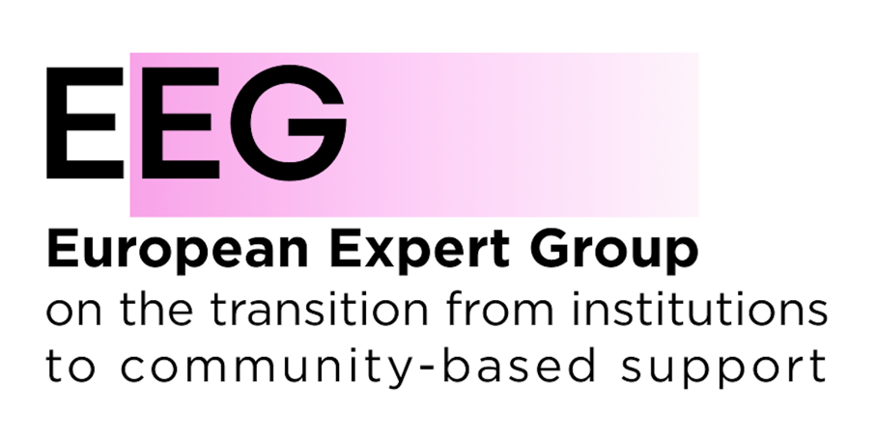

EEG Feedback on the Draft Implementing Regulation on European Statistics on Population and Housing – Datasets and Metadata
The European Expert Group on the Transition from Institutional to Community-based Support (EEG) welcomes the opportunity to provide feedback on the draft Implementing Regulation specifying the datasets and metadata to be transmitted pursuant to Regulation (EU) 2025/2458 on European statistics on population and housing.
Reliable and comparable population and housing data are essential for understanding where and how people live and for monitoring progress towards independent living, social inclusion and the transition from institutional to family- and community-based support.
The EEG therefore particularly welcomes the inclusion of persons living outside private households and the category of persons living in an “institutional household”. At present, comparable EU-level information on people living in institutional settings remains extremely limited.
However, we are concerned that some of the proposed definitions, variables and breakdowns may leave significant forms of institutionalisation statistically invisible and limit comparability between Member States. We recommend the following improvements.

1. Add a disability variable and enable cross-tabulation with housing and household status
Annex II specifies a broad range of demographic, household and housing variables, but does not include disability. This significantly limits the usefulness of the proposed statistics for understanding the living arrangements of persons with disabilities.
This is particularly important given that Regulation (EU) 2025/2458 itself recognises the persistent lack of data concerning hard-to-reach population groups, including persons residing in institutions and persons with disabilities, and encourages disaggregation by disability.
We therefore recommend adding a disability variable to Annex II, aligned where possible with existing Eurostat approaches and internationally recognised methodologies such as the Washington Group questions, and ensuring that it can be cross-tabulated with relevant variables, including household status and housing arrangements.
Without such cross-tabulation, these European statistics will remain unable to answer basic questions about where persons with disabilities live, including how many live in institutional households compared with private households.
This information is essential for monitoring the implementation of Article 19 of the UN Convention on the Rights of Persons with Disabilities (UN CRPD), which recognises the right of persons with disabilities to choose their place of residence and where and with whom they live, and not to be obliged to live in a particular living arrangement.

2. Revise the definition of “institutional household”
Annex II defines an institutional household as comprising persons whose shelter and subsistence are provided by an institution and states that:
“An institution is understood to be a legal body for the purpose of long-term habitation and provision of services to a group of persons.”
The reference to a “legal body” should be deleted.
Article 2(15) of Regulation (EU) 2025/2458 defines an institution as “collective living quarters for the purpose of providing, to a group of persons, long-term housing and services necessary for their daily life”. The basic act does not include the additional criterion of an institution being a legal body.
Beyond this specific amendment, the EEG is concerned that the proposed statistical concepts may not adequately capture all living arrangements that are institutional in nature.
From a deinstitutionalisation and human-rights perspective, an institutional setting cannot be identified solely by the legal status of a provider, the size or physical characteristics of a building, or the existence of shared facilities. Small-scale residential settings, group homes, clustered housing or other forms of supported accommodation can also reproduce institutional characteristics where people lack meaningful choice and control over where and with whom they live and over their daily lives.

3. Improve consistency between “institutional households”, “collective living quarters” and conventional dwellings
The draft defines “collective living quarters” primarily through their physical characteristics: premises designed for large groups or several households and usually involving shared facilities.
Importantly, the draft also allows premises containing small self-contained units to be classified either as a single collective living quarter or as a set of conventional dwellings, depending on national data sources, with the classification explained in metadata.
This creates a significant risk for both comparability and the visibility of institutionalisation. Similar living arrangements could be counted differently between Member States. Moreover, a residential setting could be classified statistically as conventional housing even where the organisation of support and daily life retains institutional characteristics.
The EEG therefore recommends that the Commission:
- clarify the relationship between the concepts of institutional household, collective living quarters and conventional dwellings;
- provide guidance to Member States on the classification of group homes, clustered accommodation, supported housing and similar arrangements;
- require sufficiently detailed metadata on national classification practices to identify and explain differences between Member States.
This would reduce the risk that changes in the formal size or physical structure of residential provision are statistically interpreted as progress towards community living when the underlying living arrangement has not fundamentally changed.

4. Provide more information on the type and size of institutional settings
A single aggregate category of “persons living in an institutional household” provides only limited information about the actual living arrangements of the population concerned.
Where feasible, the data should distinguish between different types of institutional or collective settings. This should allow relevant distinctions between settings accommodating different population groups, including children, persons with disabilities, older persons, persons with mental health support needs and other groups at risk of institutionalisation, while recognising that categories and forms of institutional provision vary between Member States.
For persons with disabilities specifically, such distinctions would align with the Article 19 indicator framework under the UN CRPD, developed by the Office of the United Nations High Commissioner for Human Rights, which recommends collecting data on persons with disabilities residing in different types of institutions and on transitions from institutional to independent living arrangements. The number of occupants should also be captured in a way that makes it possible to understand the size of institutional settings.
Size alone does not determine whether a setting is institutional. Nevertheless, information on both type and size, combined with household and housing classifications, would considerably improve the usefulness of the statistics.

5. Ensure comparability and sufficient frequency to monitor change
The value of these statistics will depend not only on which categories are collected but also on whether they are comparable between Member States and available frequently enough to show changes over time.
The draft provides for quarterly, annual, multi-annual and decennial datasets. The EEG recommends ensuring that key information on people living outside private households, particularly those living in institutional households, is collected and published at sufficiently regular intervals to allow meaningful monitoring of changes in living arrangements.
This is particularly relevant as Member States implement reforms and invest EU funds in the transition from institutional to family- and community-based services. Information available only at long intervals cannot provide a sufficiently timely picture of such transitions.
Consistency in classification over time and across Member States should also be addressed explicitly in the accompanying metadata.

6. Revise the proposed definition of homelessness
The EEG is concerned that the proposed definition of homeless persons is too narrow and risks excluding significant groups of people experiencing homelessness from European population and housing statistics.
The European Federation of National Organisations Working with the Homeless (FEANTSA) advocates for a broader understanding of homelessness and housing exclusion through the European Typology of Homelessness and Housing Exclusion (ETHOS). Importantly for the purpose of this Regulation, ETHOS Light has been developed as a harmonised definition of homelessness for statistical purposes.
Narrow definitions focusing primarily on people sleeping rough and those in emergency or temporary accommodation risk excluding less visible forms of homelessness from data and consequently from policy responses.
The EEG therefore recommends revising the definition of homeless persons with reference to ETHOS Light, in consultation with FEANTSA and other organisations with expertise in homelessness, with the aim of ensuring that European statistics capture relevant forms of homelessness consistently and do not systematically exclude people experiencing less visible forms of homelessness.

About the EEG
The European Expert Group on the Transition from Institutional to Community-based Support (EEG) is a broad coalition bringing together stakeholders representing people with care or support needs, including persons with disabilities, children and families, people experiencing homelessness, people with mental health problems, as well as service providers, public authorities and human rights organisations.
The EEG advocates for the transition from institutional care to family- and community-based support and for the development of high-quality, person-centred services that enable people to live independently and be included in the community.
Contact:
Mariya Yasenovska
Coordinator
European Expert Group on the Transition from Institutional to Community-based Support
coordinator@deinstitutionalisation.com

See Office of the United Nations High Commissioner for Human Rights, Statistics and data collection under article 31 of the Convention on the Rights of Persons with Disabilities, 2021
See Office of the United Nations High Commissioner for Human Rights, Article 19: Illustrative indicators on living independently and being included in the community, 2020

